Flutter Final Assignment

Info Timepass app

I created a flutter application which is a application that is used to spend one’s time productively by enhancing their the knowledge in reading rather than wasting their time in someother entertainment or social media application. For this assignment I used the concepts that are mentioned below  
1. Widgets

2. Stateless and stateful widgets

3. Styling and Theming

4. Layouts and Views

5. Navigations

6. Gestures

7. Api Calling

8. Database

9. Firebase integration

10. Localization

Here I attached the screenshot of my application.

Here is the login page for this we used firebase project and configured it and used firestore database and authentication for user credential to be stored. If I give wrong credential it shows error message

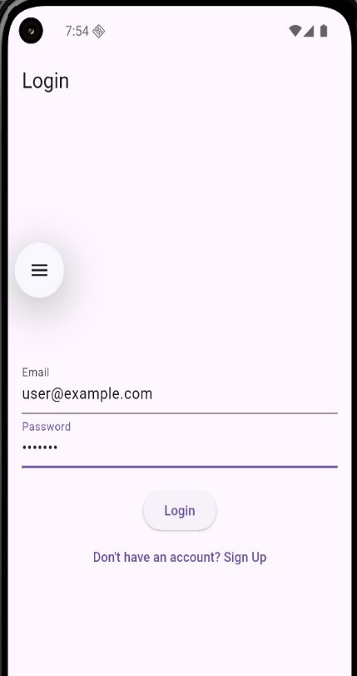

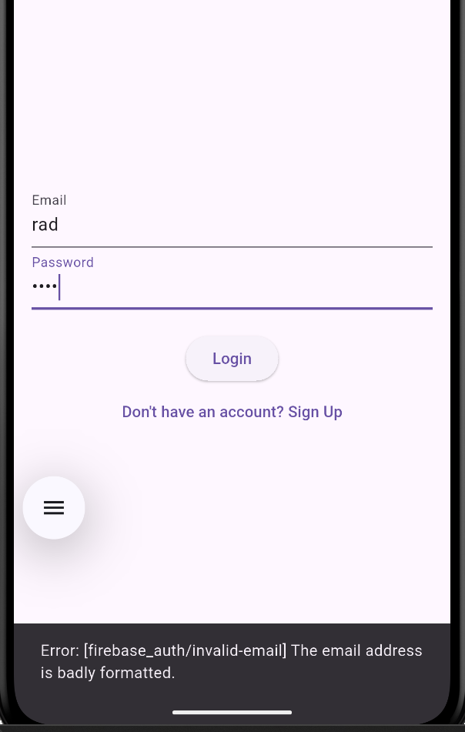

If we don’t have login credential we can signup and the signup data will be stored in the firestoredatabase.

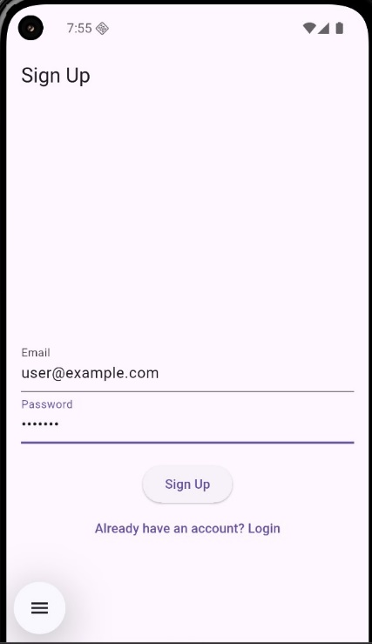

After login the page we navigate to home screen. In the home page we can see four cards which are search books, Latest news, get motivation and space facts.

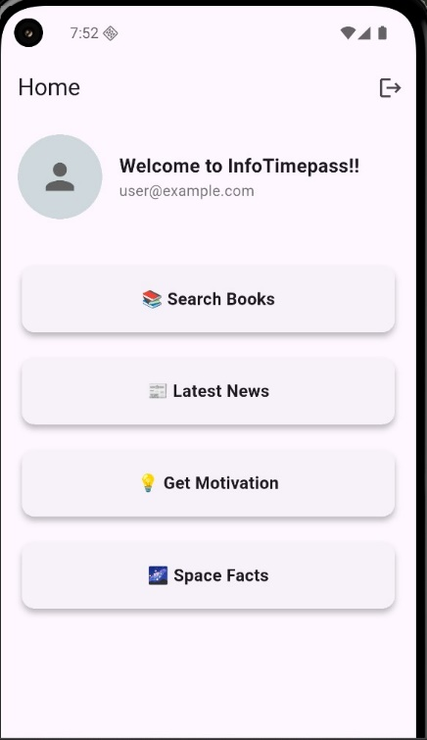

In search Books we can search the book and book will retrieved using the open API

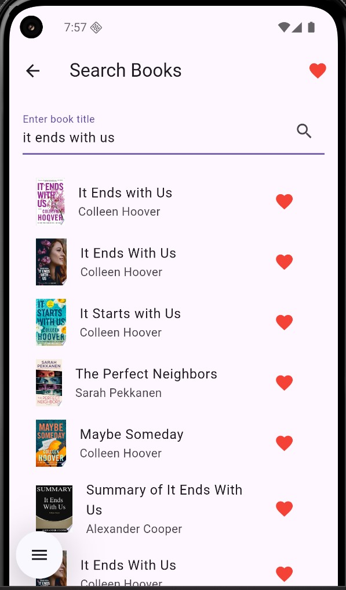

In the search book list when we select the a particular book it will show the book card.



We can add book in favorites and in the can be seen in favorites page and it show get stored in firestore database. We can also remove the book from favorites section.

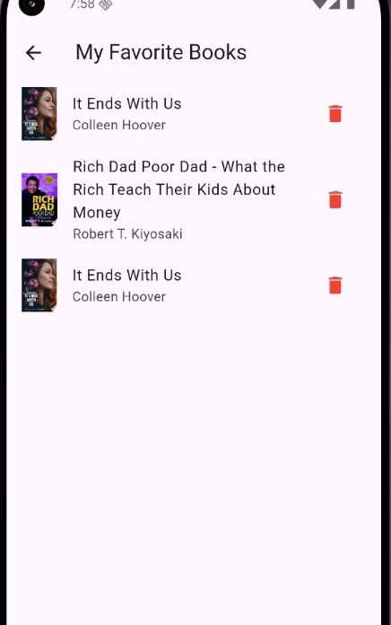

Next is the Latest news which display the news based on categories here we used news Api to retrieve the news

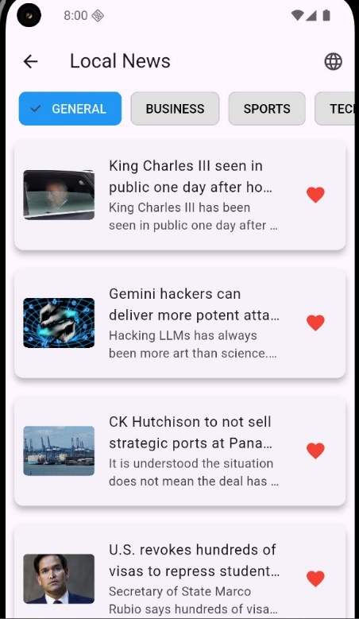

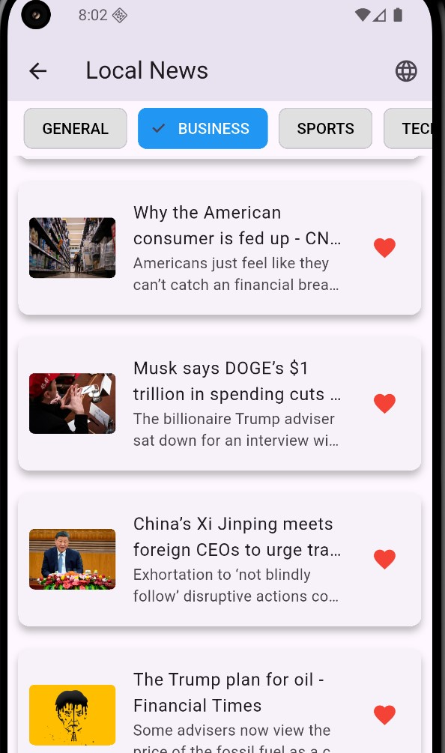

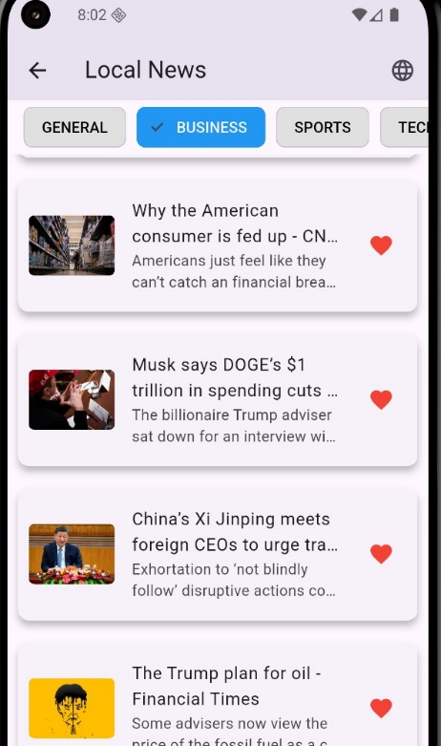

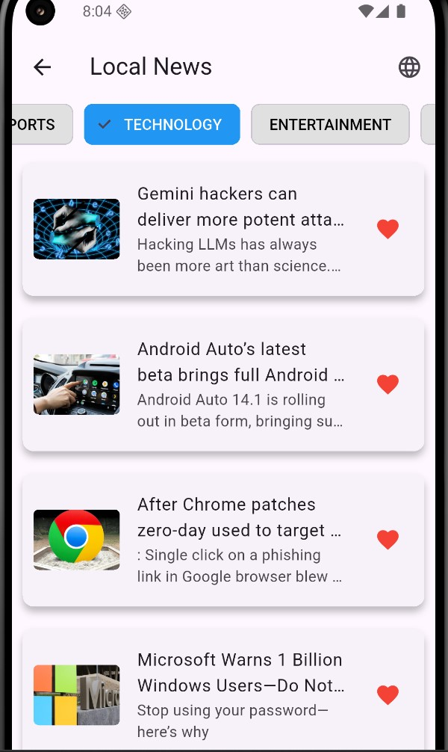

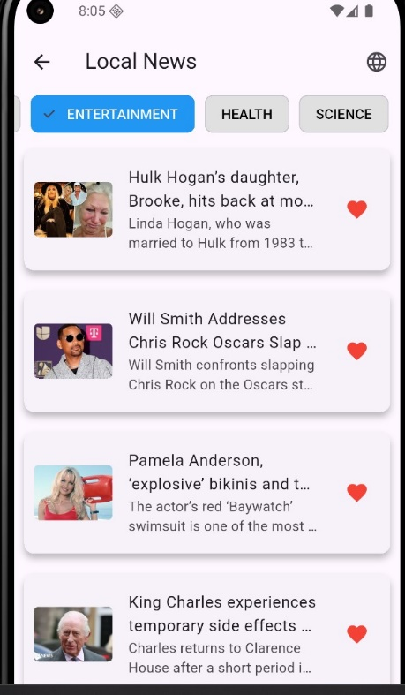

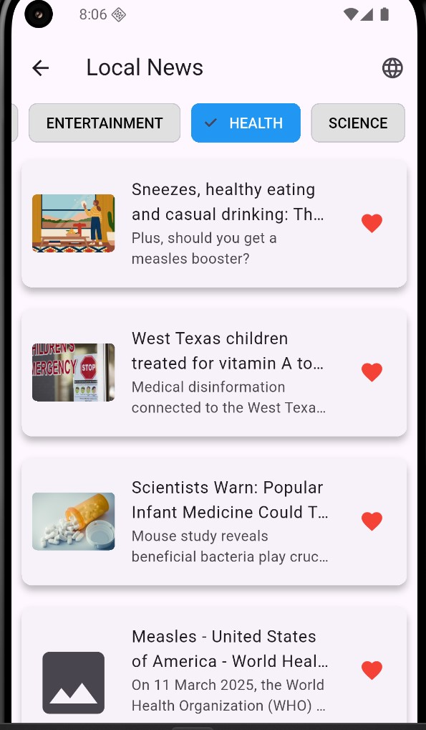

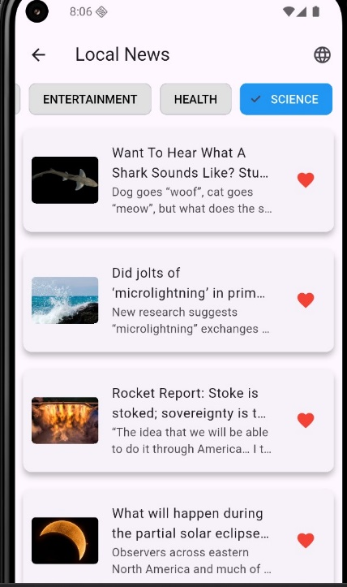

After we seen the categories of news and we can also add change the news to multiple language as we used localization here.

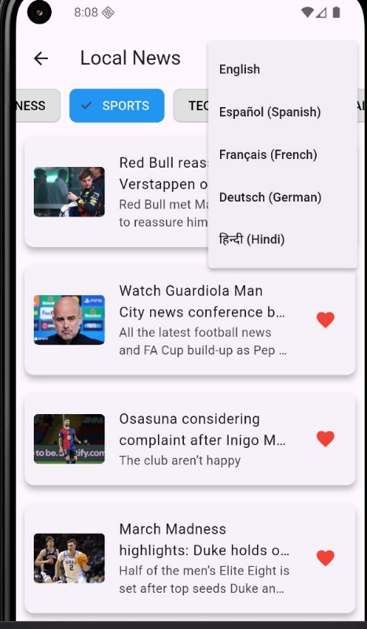

I added motivational quotes in next section as it will show the different motivational quotes everytime we open it which will make ourself motivated when we feel down.



And in the next section I added the space facts as some people were interested in knowing space facts as for retrieving the facts from nasa open api which is displayed in cards.

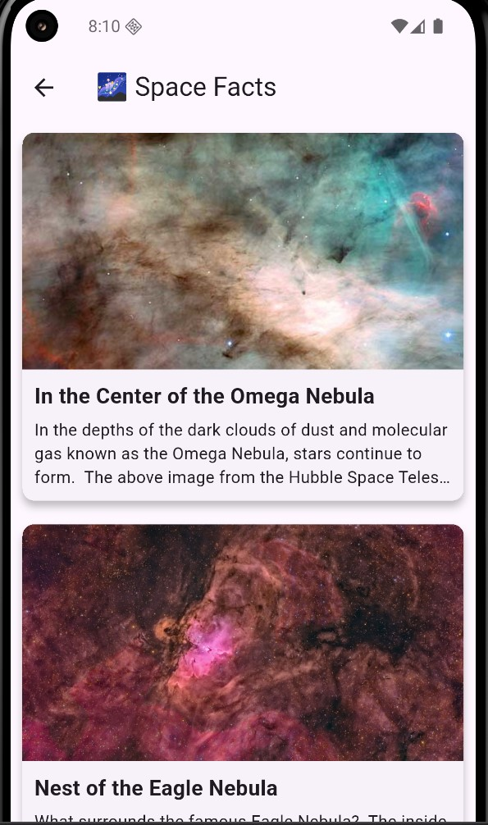

Here I attached the screenshot of firestore database and the authentication which we enable the email/password for login and signup page.

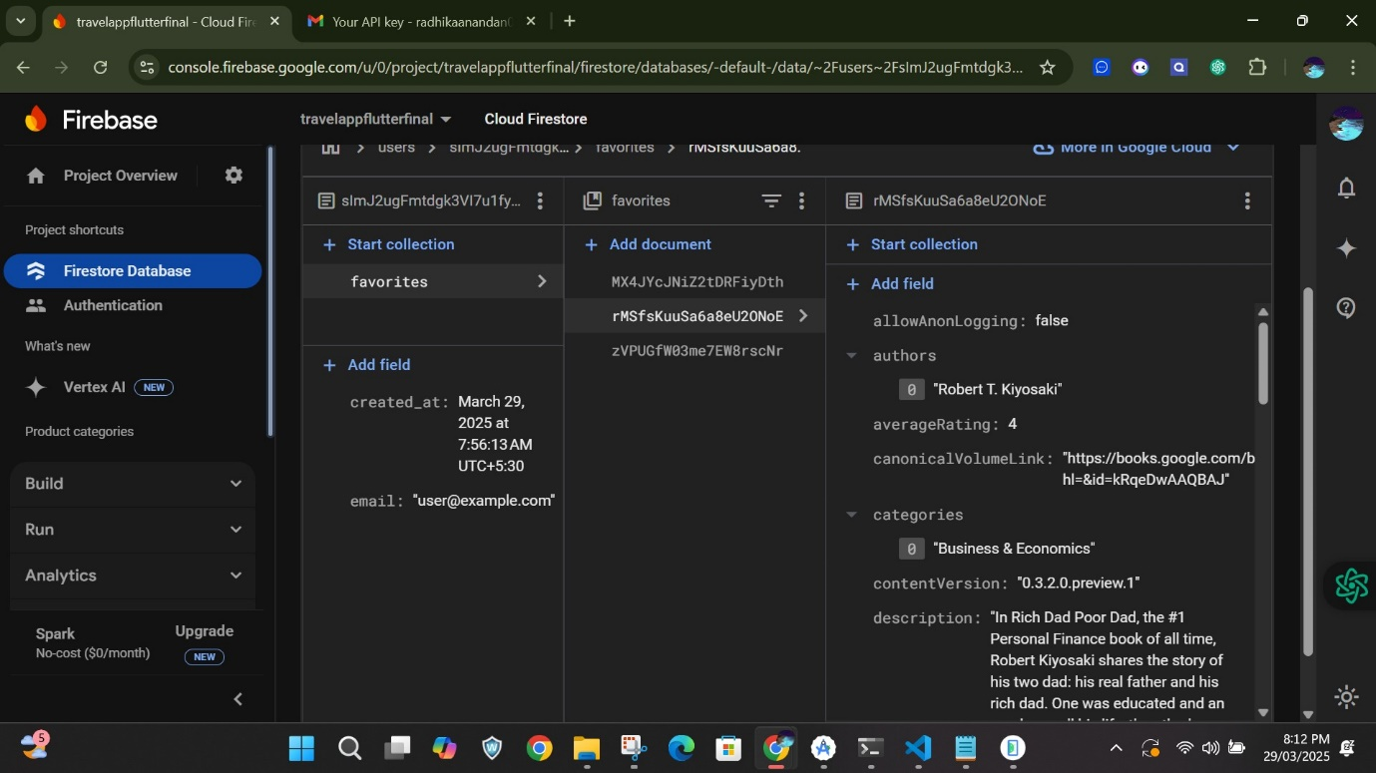

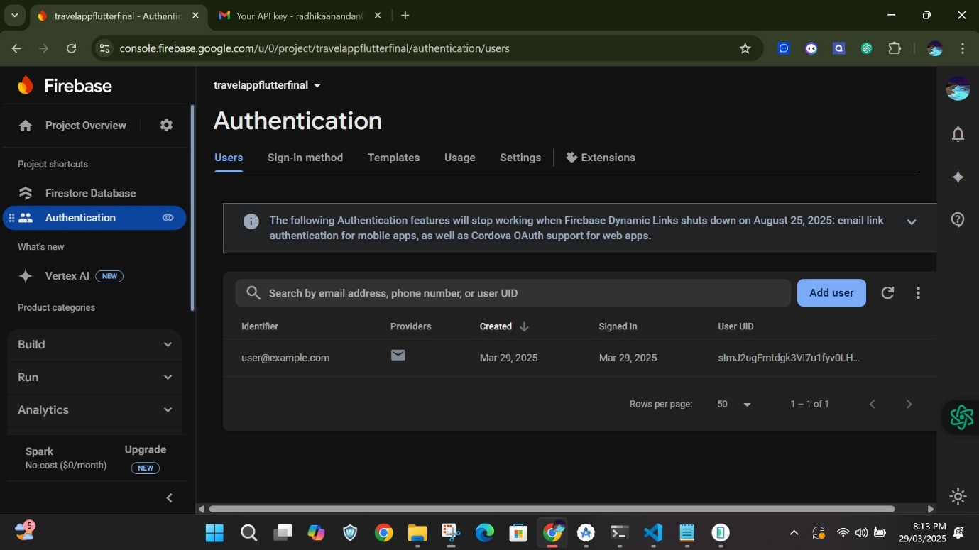

Here I attach the project when configured with firebase project.

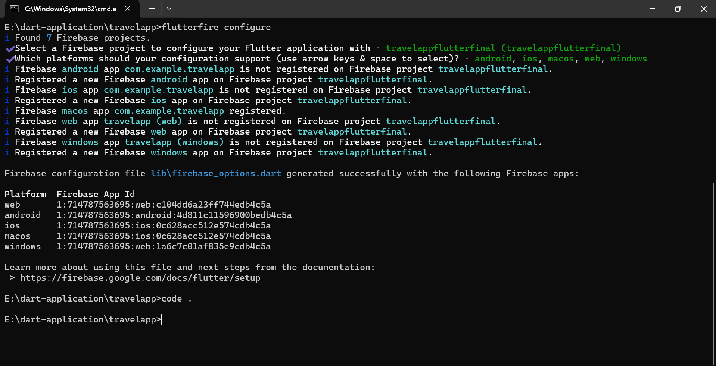

Conclusion :

Here I created the flutter project based on the requirements mentioned which is built and running successfully.